COSC344 Assignment 1

Darcy Knox

Student ID: 7712753

31 July 2020

Group of 1 (Darcy Knox)

Revised ER diagram

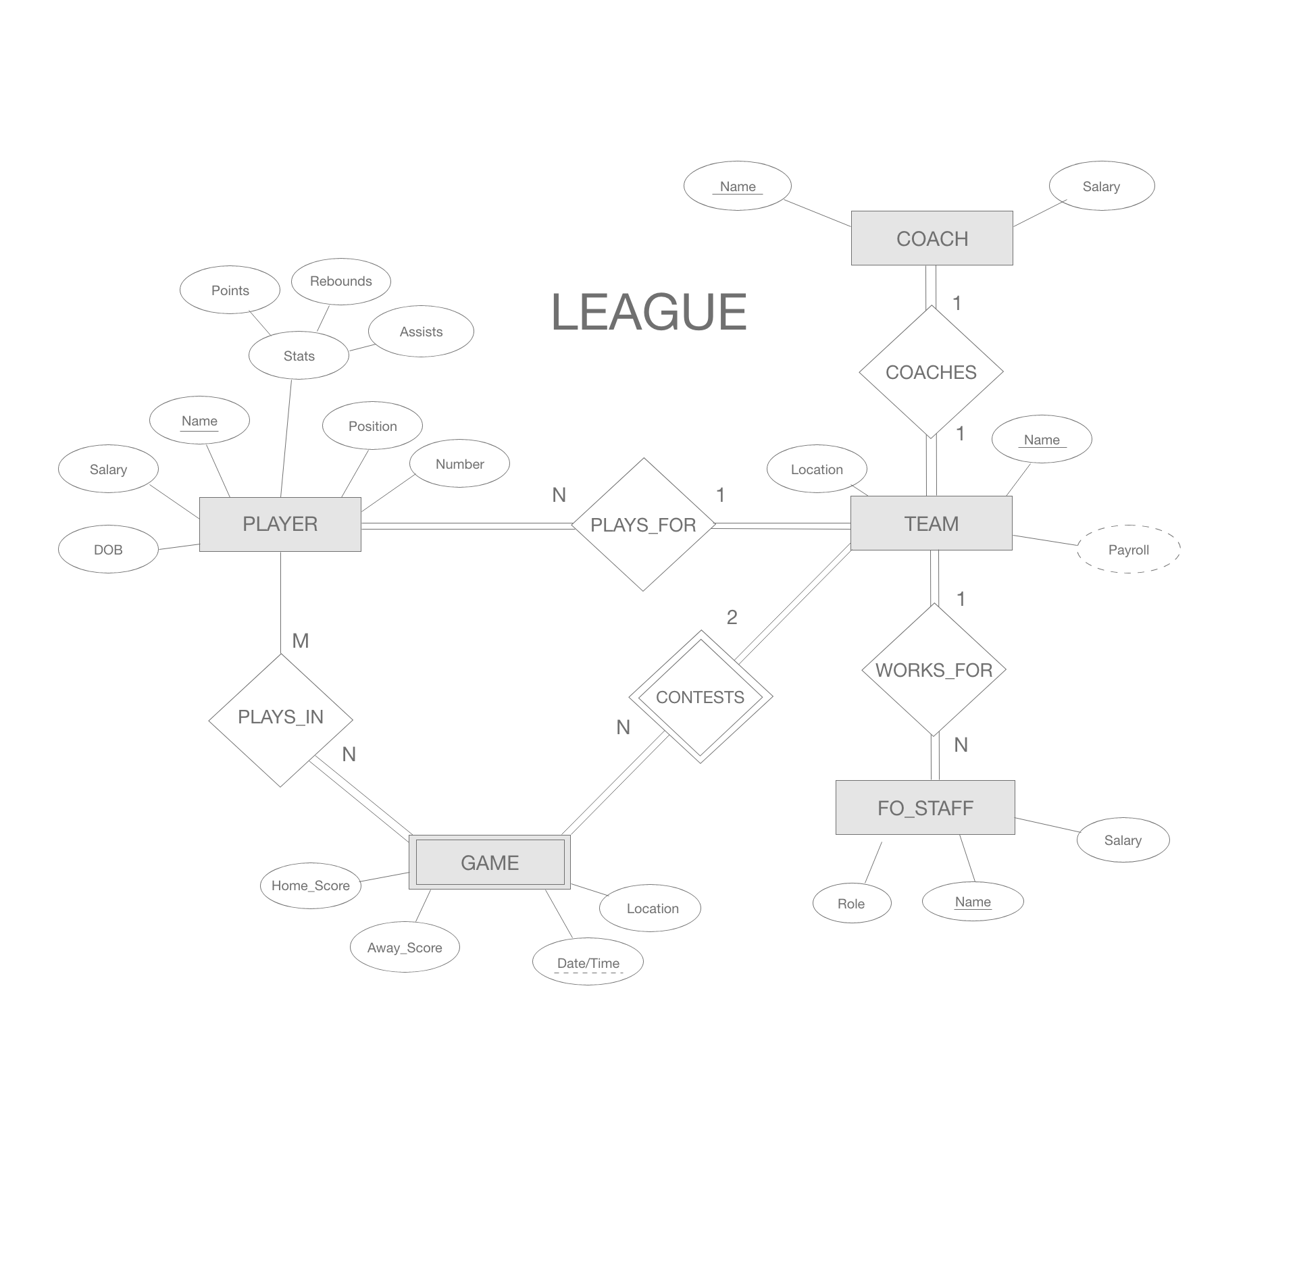

Revisions:

1. FO_STAFF no longer a weak entity type
2. COACHES relationship is full participation both ways
3. GAME is now a weak entity type with Date/time attribute as the partial key and the CONTESTS relationship as the identifying relationship.

Relational schema

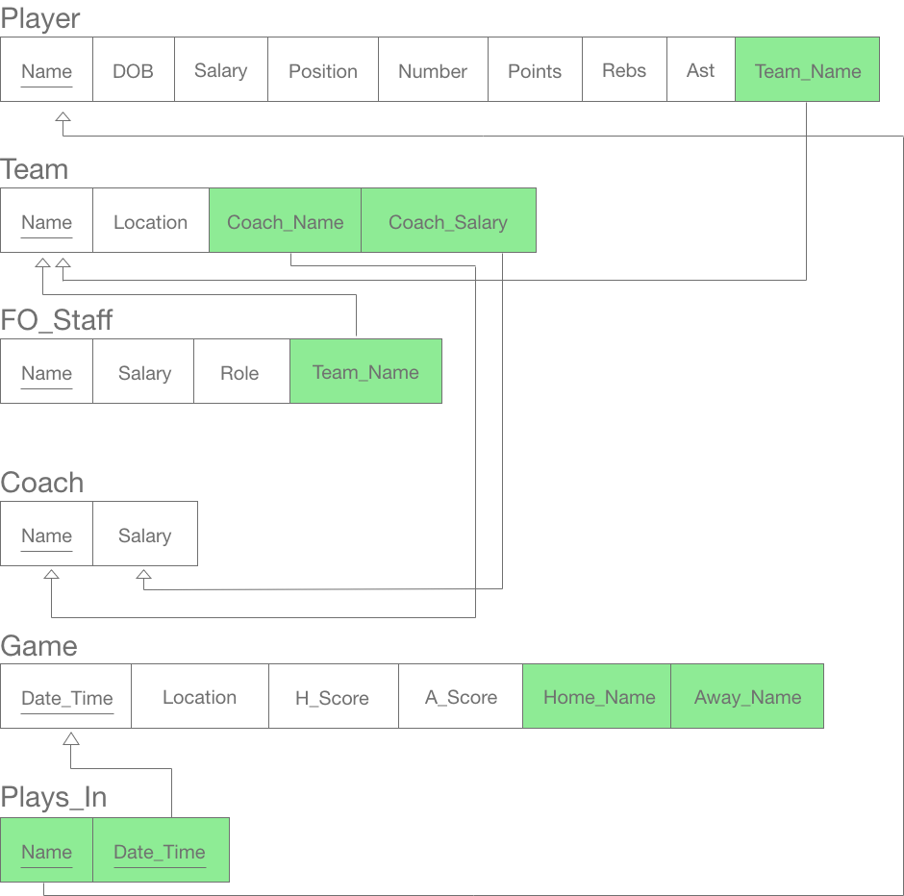

Normalisation

1NF: All relations are in 1NF. No multivalued attributes, composite attributes have been handled in the creation of the schema, no nested relations. All attribute values are atomic.

2NF: All relations are in 2NF as no partial functional dependencies exist.

3NF: No transitive dependencies exist in any relation.

BCNF: Every LHS of a functional dependency is a primary (candidate) key.

Load.sql

* Unfortunately I encountered some bugs quite late so I don’t think the code runs without error.

DROP TABLE coach;

DROP TABLE team;

DROP TABLE player;

DROP TABLE fo_staff;

DROP TABLE game;

DROP TABLE plays_in;

CREATE TABLE coach

(name VARCHAR(20) PRIMARY KEY,

salary NUMBER(8,2) UNIQUE

);

CREATE TABLE team

(name VARCHAR(20) PRIMARY KEY,

location VARCHAR2(20) NOT NULL UNIQUE,

coach_name VARCHAR2(20) CONSTRAINT cchname_fk REFERENCES coach(name) DISABLE,

coach_salary NUMBER(6,2) CONSTRAINT cchsal_fk REFERENCES coach(salary) DISABLE

);

CREATE TABLE player

(name VARCHAR2(20) PRIMARY KEY,

dob DATE NOT NULL,

salary NUMBER(8,2),

position VARCHAR2(10) CONSTRAINT check_pos CHECK (position IN('guard', 'forward', 'center')),

jersey_num INT CONSTRAINT check_jersey CHECK (jersey_num BETWEEN 0 AND 99),

points NUMBER(3,1),

rebs NUMBER(3,1),

asts NUMBER(3,1),

team_name VARCHAR2(20) CONSTRAINT player_team_fk REFERENCES team(name) DISABLE

);

CREATE TABLE fo_staff

(name VARCHAR2(20) PRIMARY KEY,

salary NUMBER(8,2),

role VARCHAR2(20),

team_name VARCHAR2(20) CONSTRAINT fo_team_fk REFERENCES team(name) DISABLE

);

CREATE TABLE game

(dt TIMESTAMP PRIMARY KEY,

location VARCHAR2(20),

home_team VARCHAR2(20),

away_team VARCHAR2(20),

home_score INT CONSTRAINT home_score_cnst CHECK (home_score BETWEEN 0 AND 200),

away_score INT CONSTRAINT away_score_cnst CHECK (away_score BETWEEN 0 AND 200)

);

CREATE TABLE plays_in

(name VARCHAR2(20) CONSTRAINT playsin_name_fk REFERENCES player(name) DISABLE,

dt TIMESTAMP CONSTRAINT playsin_dt_fk REFERENCES game(dt) DISABLE

);

COMMIT;

INSERT INTO team VALUES ('Bulls','Franklin','Liam Simmons',1000);

INSERT INTO team VALUES ('Nuggets','Otago','Brent Matehaere',1000);

INSERT INTO team VALUES ('Jets','Manawatu','Tim McTamney',1000);

INSERT INTO team VALUES ('Rams','Canterbury','Mick Downer',1000);

INSERT INTO team VALUES ('Giants','Nelson','Mike Fitchett',1000);

INSERT INTO team VALUES ('Huskies','Auckland','Kevin Braswell',1000);

INSERT INTO team VALUES ('Airs','Taranaki','Doug Courtney',1000);

COMMIT;

INSERT INTO player VALUES ('Jarrod Kenny',TO_DATE('20-08-1985', 'dd-mm-yyyy'), 6000.00, 'guard', 6, NULL, NULL, NULL, 'Nuggets');

INSERT INTO player VALUES ('Jordan Ngatai',TO_DATE('20-08-1993', 'dd-mm-yyyy'), 7000.00, 'forward', 11, NULL, NULL, NULL, 'Nuggets');

INSERT INTO player VALUES ('Matthew Bardsley',TO_DATE('08-08-1995', 'dd-mm-yyyy'), 0.00, 'guard', 7, NULL, NULL, NULL, 'Nuggets');

INSERT INTO player VALUES ('Josh Aitcheson',TO_DATE('25-05-1998', 'dd-mm-yyyy'), 3500.00, 'forward', 13, NULL, NULL, NULL, 'Nuggets');

INSERT INTO player VALUES ('Jordan Hunt',TO_DATE('20-08-1998', 'dd-mm-yyyy'), 6000.00, 'guard', 6, NULL, NULL, NULL, 'Nuggets');

INSERT INTO player VALUES ('Jayden Bezzant',TO_DATE('20-08-1996', 'dd-mm-yyyy'), 6000.00, 'guard', 6, NULL, NULL, NULL, 'Jets');

INSERT INTO player VALUES ('Tom Vodanovich',TO_DATE('20-08-1994', 'dd-mm-yyyy'), 7000.00, 'forward', 32, NULL, NULL, NULL, 'Jets');

INSERT INTO player VALUES ('Ashton McQueen',TO_DATE('20-08-1995', 'dd-mm-yyyy'), 0.00, 'guard', 95, NULL, NULL, NULL, 'Jets');

INSERT INTO player VALUES ('Taane Samuels',TO_DATE('20-08-1998', 'dd-mm-yyyy'), 5000.00, 'forward', 20, NULL, NULL, NULL, 'Jets');

INSERT INTO player VALUES ('Derone Raukawa',TO_DATE('20-08-1994', 'dd-mm-yyyy'), 6000.00, 'guard', 8, NULL, NULL, NULL, 'Airs');

INSERT INTO player VALUES ('Marcel Jones',TO_DATE('20-08-1988', 'dd-mm-yyyy'), 7000.00, 'forward', 76, NULL, NULL, NULL, 'Airs');

INSERT INTO player VALUES ('Taylor Britt',TO_DATE('20-08-1996', 'dd-mm-yyyy'), 6000.00, 'guard', 5, NULL, NULL, NULL, 'Rams');

INSERT INTO player VALUES ('Reuben Te Rangi',TO_DATE('20-08-1994', 'dd-mm-yyyy'), 7000.00, 'forward', 7, NULL, NULL, NULL, 'Rams');

INSERT INTO player VALUES ('Mike Karena',TO_DATE('20-08-1993', 'dd-mm-yyyy'), 6000.00, 'guard', 35, NULL, NULL, NULL, 'Giants');

INSERT INTO player VALUES ('Mika Vukona',TO_DATE('20-08-1982', 'dd-mm-yyyy'), 7000.00, 'forward', 8, NULL, NULL, NULL, 'Giants');

INSERT INTO player VALUES ('Sam Timmins',TO_DATE('20-08-1997', 'dd-mm-yyyy'), 6000.00, 'guard', 4, NULL, NULL, NULL, 'Bulls');

INSERT INTO player VALUES ('Dom Kelman-Poto',TO_DATE('20-08-1994', 'dd-mm-yyyy'), 7000.00, 'forward', 10, NULL, NULL, NULL, 'Bulls');

INSERT INTO player VALUES ('Izayah Mauriohooho-Leafa',TO_DATE('20-08-1996', 'dd-mm-yyyy'), 6000.00, 'guard', 4, NULL, NULL, NULL, 'Huskies');

INSERT INTO player VALUES ('Tohi Smith-Milner',TO_DATE('20-08-1995', 'dd-mm-yyyy'), 7000.00, 'forward', 14, NULL, NULL, NULL, 'Huskies');

COMMIT;

INSERT INTO coach VALUES ('Brent Matehaere', 1000);

INSERT INTO coach VALUES ('Mick Downer', 1000);

INSERT INTO coach VALUES ('Mike Fitchett', 1000);

INSERT INTO coach VALUES ('Kevin Braswell', 1000);

INSERT INTO coach VALUES ('Liam Simmons', 1000);

INSERT INTO coach VALUES ('Doug Courtney', 1000);

INSERT INTO coach VALUES ('Tim McTamney', 1000);

COMMIT;

INSERT INTO fo_staff ('Angela Ruske',1000,'General Manager','Nuggets');

INSERT INTO fo_staff ('Matt Lacey',1000,'General Manager','Huskies');

INSERT INTO fo_staff ('Caleb Harrison',1000,'General Manager','Rams');

INSERT INTO fo_staff ('Jamie Reddish',1000,'General Manager','Bulls');

INSERT INTO fo_staff ('Paul Jones',1000,'General Manager','Giants');

INSERT INTO fo_staff ('Mitchell Langton',1000,'General Manager','Airs');

INSERT INTO fo_staff ('Josiah Clancy',1000,'General Manager','Jets');

COMMIT;

INSERT INTO game VALUES (TIMESTAMP'2020-06-08 17:30:00','Otago','Nuggets','Jets',104,100);

INSERT INTO game VALUES (TIMESTAMP'2020-06-10 19:30:00','Nelson','Giants','Rams',88,90);

INSERT INTO game VALUES (TIMESTAMP'2020-06-12 17:30:00','Taranaki','Airs','Huskies',92,81);

INSERT INTO game VALUES (TIMESTAMP'2020-06-14 19:00:00','Canterbury','Rams','Nuggets',77,76);

INSERT INTO game VALUES (TIMESTAMP'2020-06-15 19:00:00','Manawatu','Jets','Nuggets',102,110);

INSERT INTO game VALUES (TIMESTAMP'2020-06-16 17:00:00','Nelson','Giants','Huskies',80,86);

INSERT INTO game VALUES (TIMESTAMP'2020-06-17 19:00:00','Otago','Nuggets','Airs',80,81);

INSERT INTO game VALUES (TIMESTAMP'2020-06-18 17:00:00','Canterbury','Rams','Nuggets',90,95);

COMMIT;

Teamwork summary

I have done this assignment by myself. I can see how this assignment would have been a good experience to do in a group. I felt like I needed more than one perspective on a few things that may be a bit more subjective in terms of the relational model, and what should be considered what.